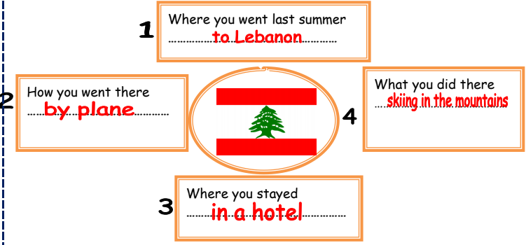

A holiday in Lebanon
I went to Lebanon last summer. I there went by plane. I stayed in a hotel. I went skiing in the mountains.

