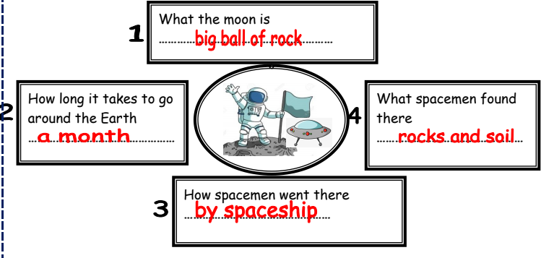

The moon
The moon is a big a ball of rock. It takes a month to go around the Earth. The spacemen went there by spaceship. Spacemen found rocks and soil there.

