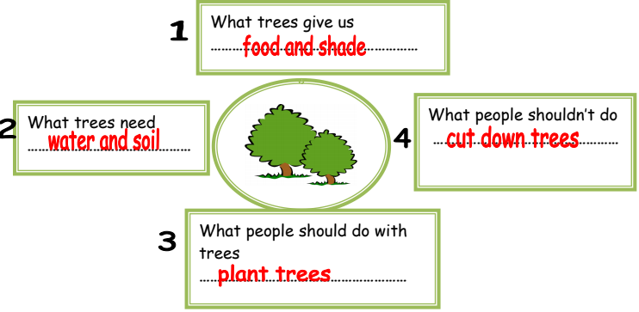
Planting trees
Trees give us food and shade. Trees need water and soil. People should plant trees. People shouldn’t cut down trees.

