The Sadu House

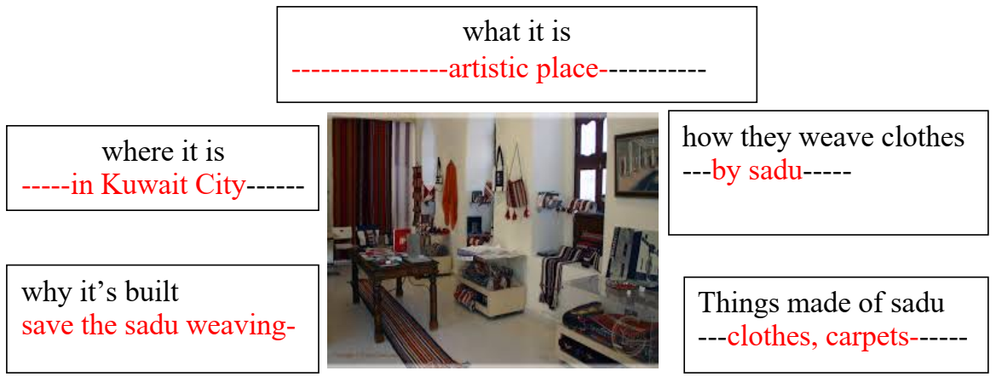

The sadu house is an artistic place. It is in Kuwait City. It’s built to save the sadu weaving heritage. They are weaving clothes by the sadu. They weave sadu to make clothes , carpets, mats and bags.

