Dickson House

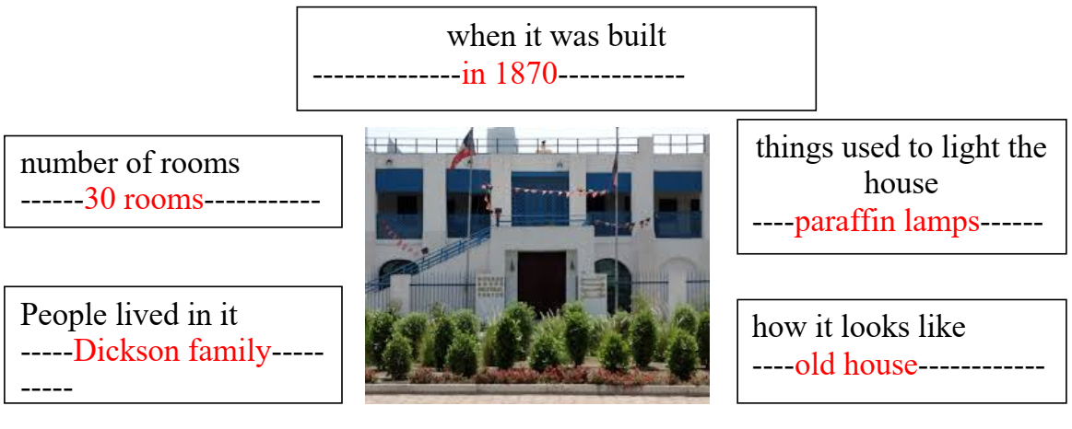

Dickson House was built in 1870. There are 30 rooms in the house. Dickson family lived there in the past. They used paraffin lamps to light their house. It looks like an old house.

